Explorations of the East: Number 3 – THE GREENWAY

This is a walk of about 4 or 5 miles through the transformed area of Hackney Wick, and out east.
It is interesting because it is a walk on top of a sewage pipe. This takes our sewage, from the City and North London, to the Sewage Treatment Works at Beckton.
You see the 21st century buildings in the Olympic Park, the marvellous Abbey Mills pumping station, large unexpected stretches of water and a lot of suburban houses. I enjoyed this walk as an appreciation of an engineering marvel. I wonder at the vision of those Victorian engineers who built this sewer. It’s salutary to be reminded of the critical infrastructure that keeps London going, and the unsung engineers and operators who maintain it.

The Greenway is a straight well-maintained path between grass and trees. The path is elevated, so in winter you have great views over areas of London. There are trees on both sides of the path for much of the route, so in summer you won’t have the views. It is a sensory walk. There are sights and sounds, including birdsong. Being on top of a sewer pipe, there is something of a fermenting-type smell in places.

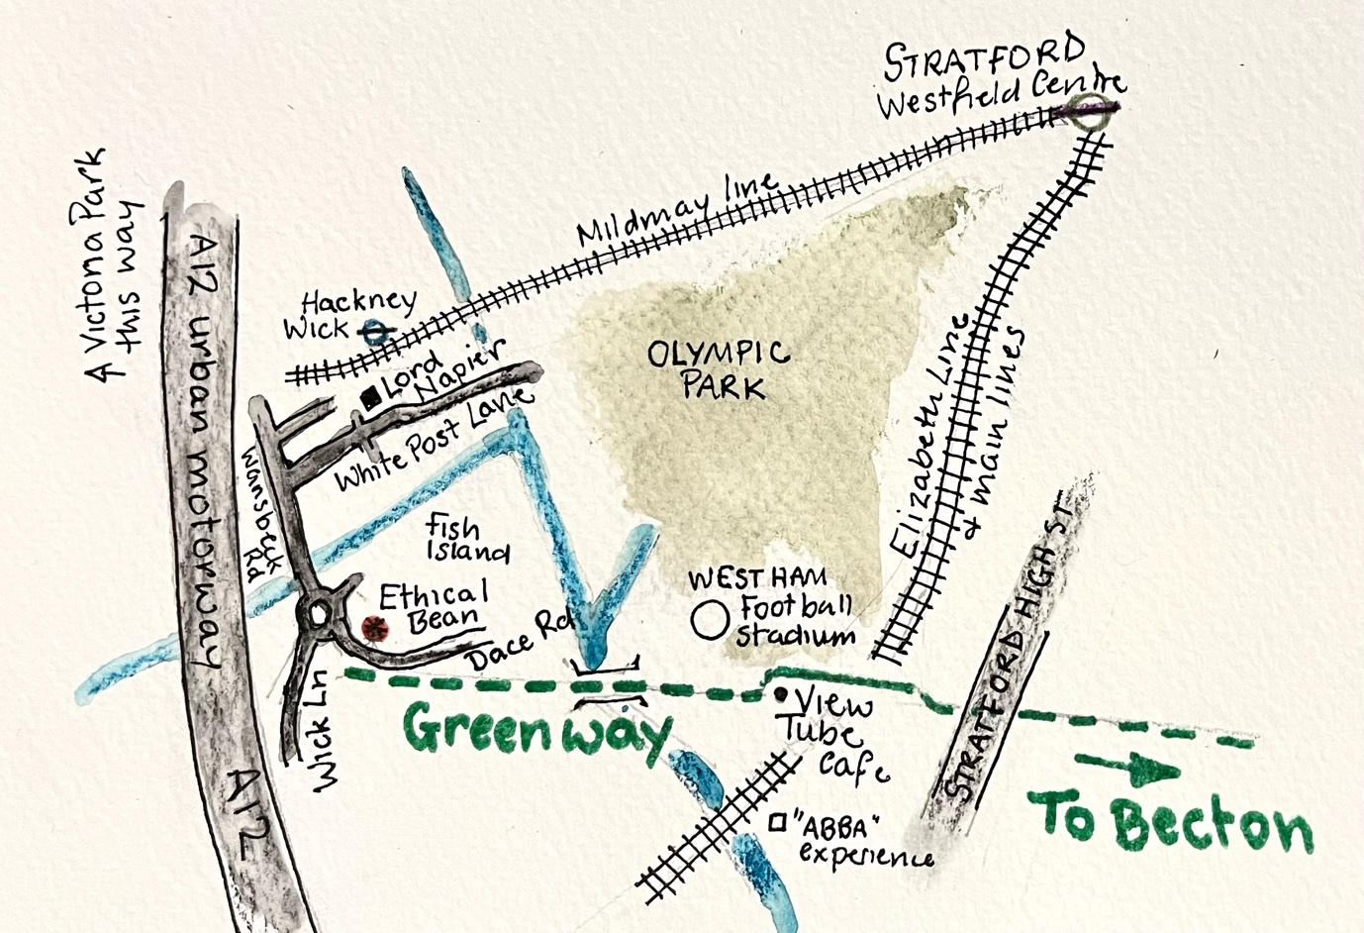
The walk starts in Hackney Wick. Hackney Wick station is on the Mildmay Line. From central London you go east to Stratford on the Elizabeth Line and then change and go one stop west to Hackney Wick.

Arriving in Hackney Wick, the first task is to find Ethical Bean, which is a café.

To find Ethical Bean from Hackney Wick, find White Post Lane, which is signposted, and walk past the pub “Lord Napier” on your right.
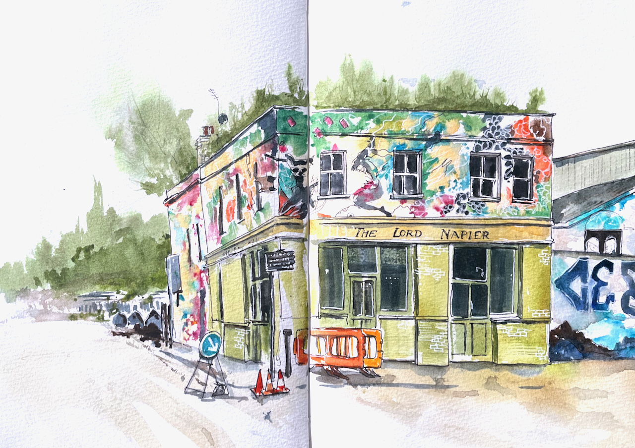
You reach Wansbeck Road. Follow this road south, with the big A12 urban motorway on your right, high up. There is a bridge over a canal, and many construction sites next to the canal. This area is called “Fish Island”.
Then there’s a roundabout. Do not take Wick Lane. Do not take Monier Road. Bear left into Dace Road, see map above.

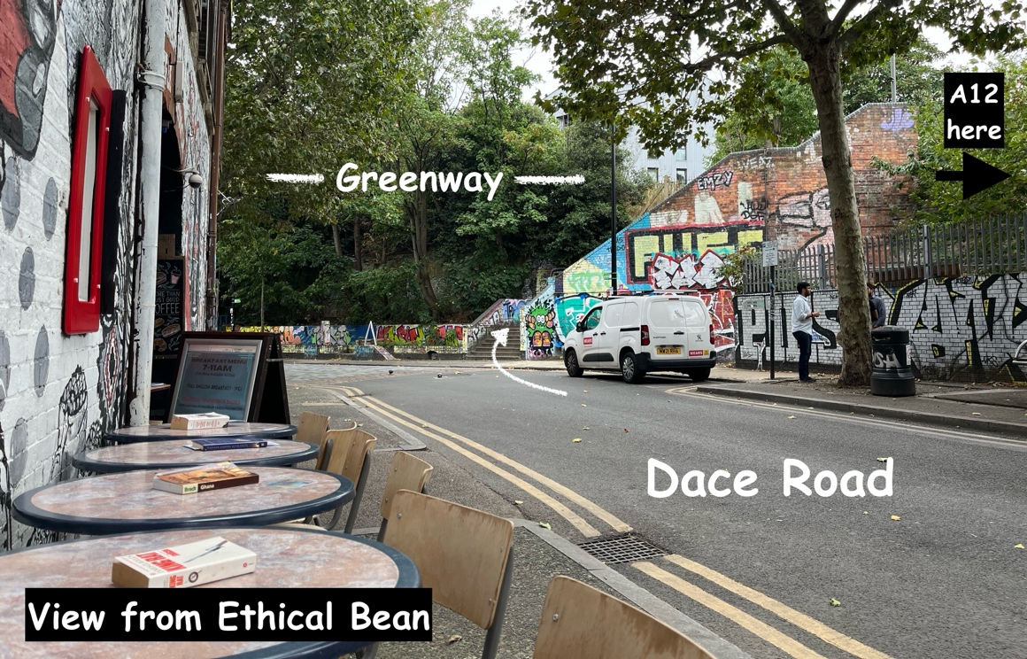
Soon you find Ethical Bean, with chairs and tables outside, on a corner.
From the tables outside you see trees high up. This is the Greenway.

For an interesting diversion, you can continue a little way along Dace Road, and find the London Centre for Book Arts on the right. They often have a small exhibition. You see many old warehouses. All of Hackney Wick used to be like this.

From Ethical Bean, go across the road and up the stairway amongst the graffiti. See photo above. Then you find the Greenway at the top. Turn left.
The path leads off in a straight line. Stay on this elevated path over small rivers. Pass the Olympic Park which is on your left.

After half a mile, you see the West Ham Stadium on your left, clearly labelled. Then the Greenway goes into a café called “The View Tube” and stops. You have to take a diversion. Just before “The View Tube” there are ways off to left and right. The simplest is to go downhill left (towards the Olympic park), and then follow this path as it bends right, to go parallel to the route of the sewer pipe which is above right. There are several railway lines which are below left. In 50 metres you cross a busy road which is Shoreditch High Street, and you pick up the Greenway again on the other side of this road. See map above.

Now it is straight on, following the path all the way to Becton.

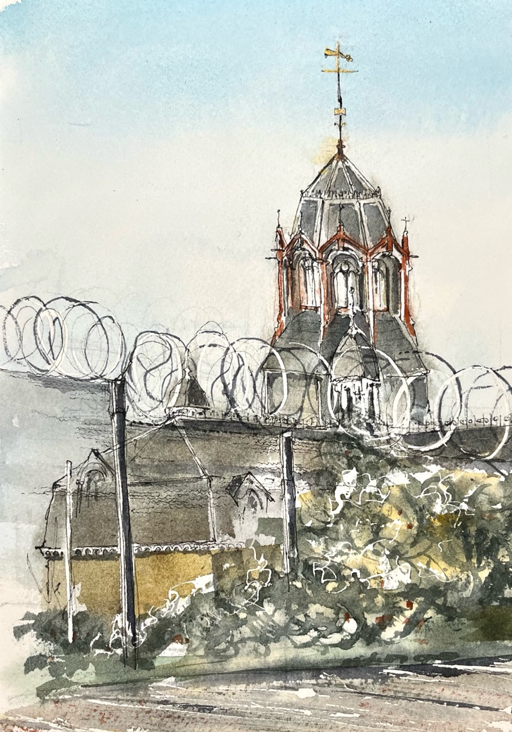
A few hundred metres after Stratford High Street, you pass the magnificent Abbey Mills Pumping Station on your right. This was built in 1865-68, as was the sewer pipe below your feet. Joseph Bazelgette was the engineer and visionary behind this, with Edward Cooper. The architect was Charles Driver. The pumping station lifts raw sewage 40 ft from the lower level sewers into the higher sewer we are standing on, and so to Beckton. In Bazelgette’s day, the pumps were steam driven: there were 8 of them.
Abbey Mills pumping station
sketched from the Greenway
Now they are electric. The Thames Water site says “ In 1933 our plant was installed consisting of eight electrically driven pumps with an overall capacity of 224,000 gallons a minute. [… ] The plant can pump almost all the dry weather flow from the lower parts of North London.”

This is an operational pumping station and you cannot go inside. That’s a pity because the Thames Water site shows the amazing Victorian decorated ironwork inside, which was restored in 2015. There are organised tours for groups and on certain occasions.
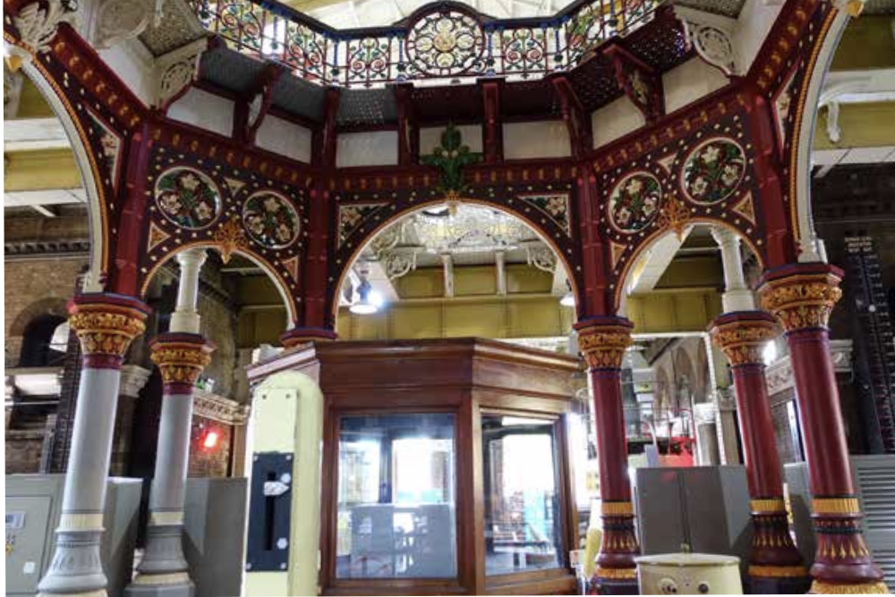
Inside Abbey Mills pumping Station. Photo: Thames Water
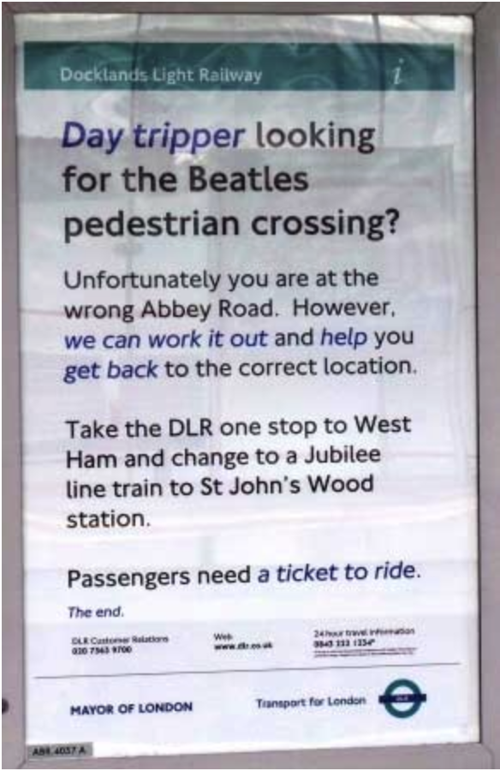
However you can admire it from outside.
There are benches here if you need a rest. Abbey Road DLR Station is nearby. This Abbey Road is not the Abbey Road in St John’s Wood where the Beatles were photographed walking across a zebra crossing. Transport for London helpfully put a notice to this effect.

When I walked the Greenway, there was a small diversion after the Abbey Mill Pumping Station, where Thames Water were mending a bridge at Manor Road. The diversion was clearly signposted and I rejoined the Greenway without a problem.

It’s about another 3 miles from here to Beckton.

I came off the Greenway at a major road interchange with the A13 and A117.
This was a few hundred metres short of the end of the Greenway, but it was getting dark. If you make it right to the end please let me know what happens.
The Greenway at the A13. My route under the A13 to Becton DLR.
Becton Alps are fenced off.
Map © OpenStreetMapContributors.

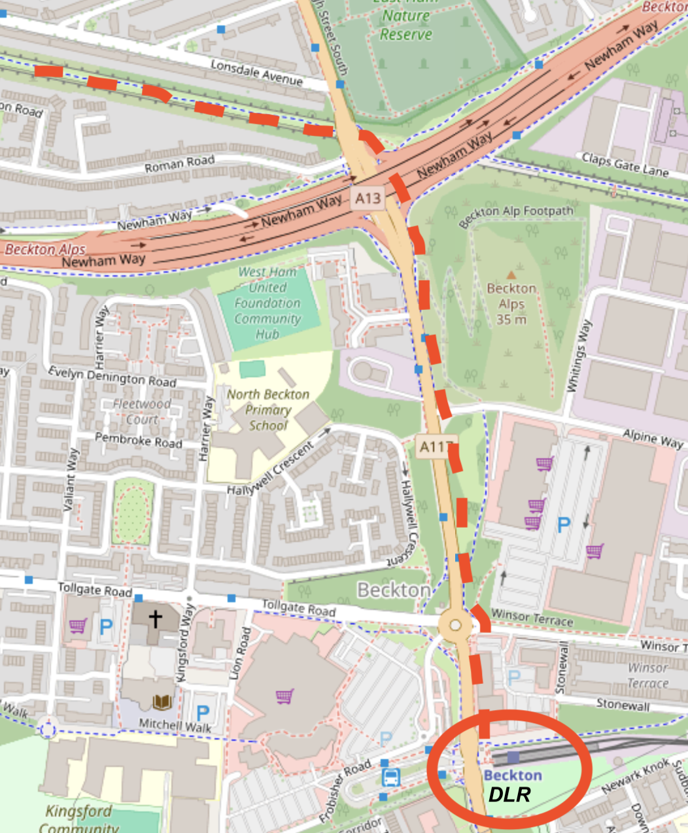

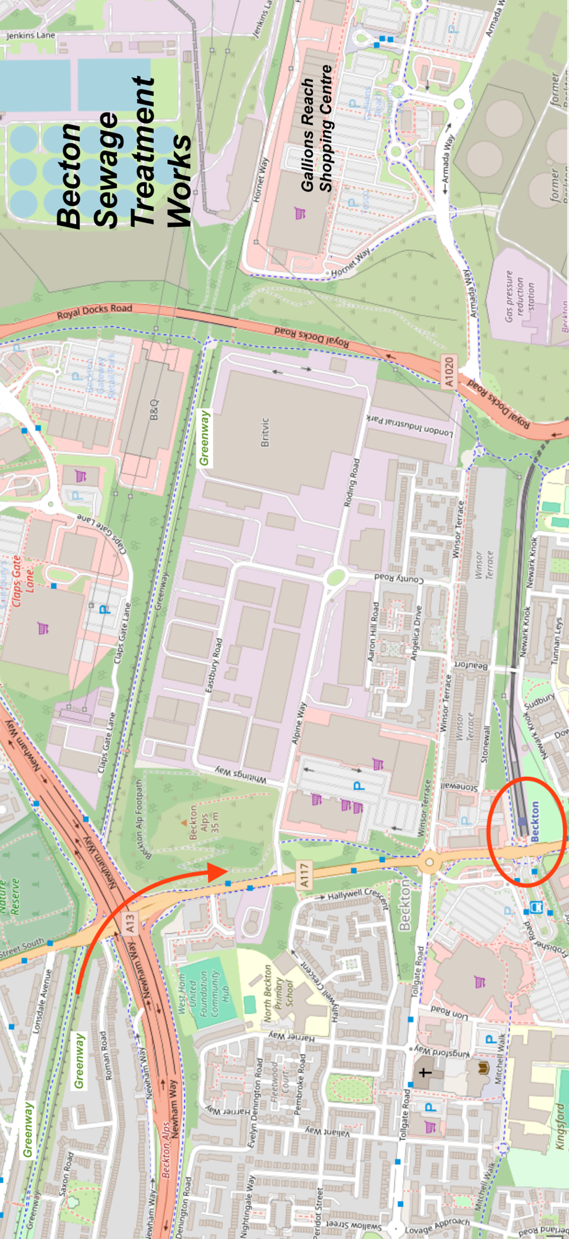

The end of the greenway. Map © OpenStreetmap Contributors

